Find-A-Gene – BGGN 213 – Spring 2019
A Geffre – A53267765

Please find below my submission for Q1-Q4, for the Find-A-Gene Project:

Questions:

[Q1]
Tell me the name of a protein you are interested in. Include the species and the accession number. This can be a human protein or a protein from any other species as long as it's function is known. If you do not have a favorite protein, select human RBP4 or KIF11. Do not use beta globin as this is in the worked example report that I provide you with online.

Protein of Interest: PGRP-S2; peptidoglycan recognition protein S2 (Apis mellifera)
>NP_001157188.1 peptidoglycan-recognition protein S2 precursor [Apis mellifera]
MTKLIAVLFLLVNCQILFCSVHETPVRPRIISRSEWGARKPTTTIRALAQNPPPFVIIHHSATDSCITQA
ICNARVRSFQNYHIDEKGWGDIGYQFLVGEDGNIYEGRGWDKHGAHSISYNSKSIGICIIGNFVGHTPNA
AAIEATKNLISYGVAIGKIQSNYTLLGHRQTTRTSCPGDSLYELIKTWPHWSSI
Accession Number: Gene ID: 412484
Gene: NM_001163716.1
Protein: NP_001157188.1

Related to anti-viral immune response in honey bees (Nazzi F, Brown SP, Annoscia D, et al. Synergistic parasite-pathogen interactions mediated by host immunity can drive the collapse of honeybee colonies. PLoS Pathog. 2012;8(6):e1002735. doi:10.1371/journal.ppat.1002735).

[Q2]
Perform a BLAST search against a DNA database, such as a database consisting of genomic DNA or ESTs. The BLAST server can be at NCBI or elsewhere. Include details of the BLAST method used, database searched and any limits applied (e.g. Organism).
tBLASTn search ID: DA9TFDNZ014, searching est (Database of GenBank+EMBL+DDBJ sequences from EST Division) database.

Also include the output of that BLAST search in your document. If appropriate, change the font to Courier size 10 so that the results are displayed neatly. You can also screen capture a BLAST output (e.g. alt print screen on a PC or on a MAC press ⌘-shift-4. The pointer becomes a bulls eye. Select the area you wish to capture and release. The image is saved as a file called Screen Shot [].png in your Desktop directory). It is not necessary to print out all of the blast results if there are many pages.

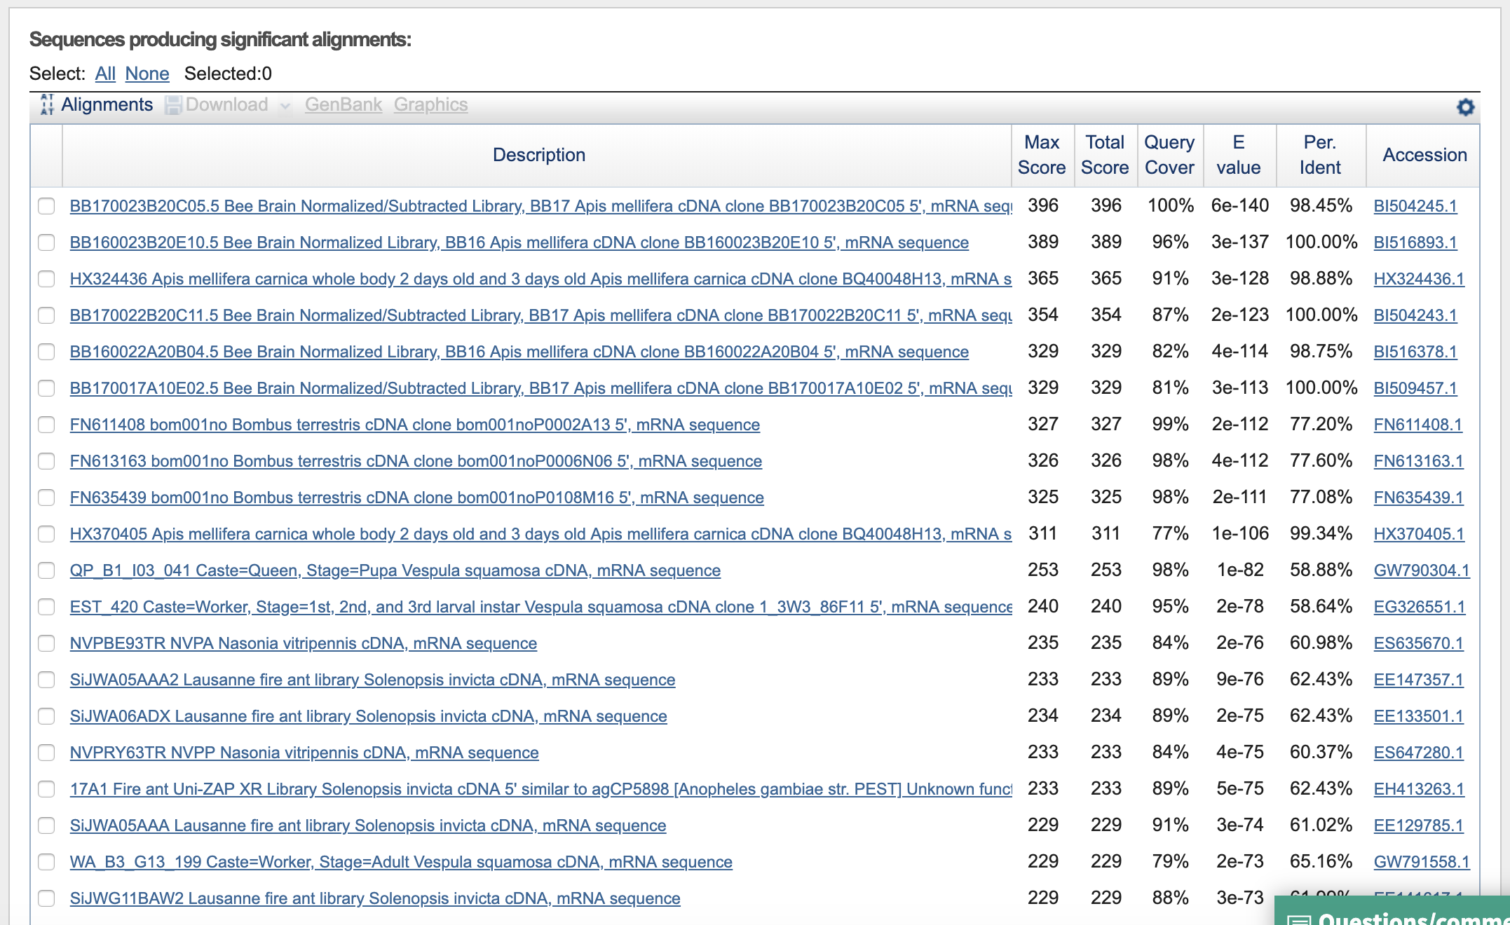
An overview of the top hits:

Some select hits of interest:
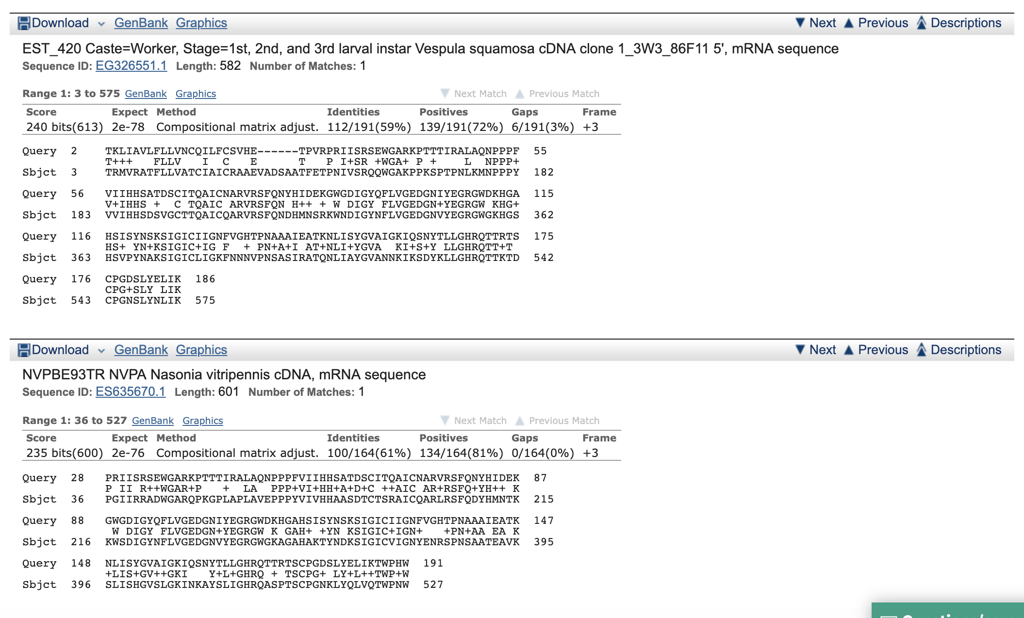
On the BLAST results, clearly indicate a match that represents a protein sequence, encoded from some DNA sequence, that is homologous to your query protein. I need to be able to inspect the pairwise alignment you have selected, including the E value and score. It should be labeled a "genomic clone" or "mRNA sequence", etc. - but include no functional annotation.

I am interested in FN611408.1 (Bombus terrestris); GW790304.1, (Vespula squamosa); EE147357.1 (Solenopsis invicta), ES647280.1 (Nasonia vitripens) etc.

All of these sequences appear to be hitherto unannotated mRNAs, all of which belong to Hymenopterans. Vespula squamosa is likely the most under-annotated, as it is not a model organism or agriculturally-relevant species.

In general, [Q2] is the most difficult for students because it requires you to have a “feel” for how to interpret BLAST results. You need to distinguish between a perfect match to your query (i.e. a sequence that is not “novel”), a near match (something that might be “novel”, depending on the results of [Q4]), and a non-homologous result. If you are having trouble finding a novel gene try restricting your search to an organism that is poorly annotated.

[Q3]
Gather information about this “novel” protein. At a minimum, show me the protein sequence of the “novel” protein as displayed in your BLAST results from [Q2] as FASTA format (you can copy and paste the aligned sequence subject lines from your BLAST result page if necessary) or translate your novel DNA sequence using a tool called EMBOSS Transeq at the EBI. Don’t forget to translate all six reading frames; the ORF (open reading frame) is likely to be the longest sequence without a stop codon. It may not start with a methionine if you don’t have the complete coding region. Make sure the sequence you provide includes a header/subject line and is in traditional FASTA format. Here, tell me the name of the novel protein, and the species from which it derives. It is very unlikely (but still definitely possible) that you will find a novel gene from an organism such as S. cerevisiae, human or mouse, because those genomes have already been thoroughly annotated. It is more likely that you will discover a new gene in a genome that is currently being sequenced, such as bacteria or plants or protozoa.

Below follows the FASTA sequence for the cDNA clone from V. squamosa
>GW790304.1 QP_B1_I03_041 Caste=Queen, Stage=Pupa Vespula squamosa cDNA, mRNA sequence
CGAGAATGGTACGAGCAACGTTTCTACTTGTTGCAACGTGCATTGCAATTTGCCGTGCAGCGGAAGTTGCAGATTCGGCT
GCAACCTTTGAAACACCTAATATCGTTTCAAGACAACAATGGGGAGCTAAACCGCCGAAAAGCCCTACGCCTAATCTTAA
AATGAATCCACCTCCTTACGTTGTTATTCATCATTCGGATTCAGTTGGTTGTACCACTCAAGCAATTTGTCAGGCTAGAG
TTAGAAGTTTTCAGAATGATCATATGAACTCGAGAAAATGGAATGACATCGGCTACAACTTTTTGGTCGGTGAAGATGGT
AATGTTTACGAAGGTCGTGGCTGGGGTAAACATGGCTCCCATTCAGTCCCGTACAATGCCAAGAGTATCGGTATTTGCCT
TATTGGTAAATTTAACAATAACGTACCGAATTCAGCGAGTATTCGAGCAACACAAAATTTGATAGCTTACGGAGTAGCTA
ACAACAAAATCAAATCCGATTATAAGCTTCTTGGCCATCGACAAACCACTAAAACTGATTGTCCTGGAAATTCTCTATAC
AATTTGATTAAAACATGGCCTCACTGGACCGACACGCCATAAGAAATATAATCGTTATGCGATTAAATTAATCTACCAAG
TATAACGTCTTATTGTTTTGGACTCGACGATCATTGGAAATTAACGATCATCGGATCGATAACTTTTGTTGACTTTTCTT
TAATTAACGATGGATACCTTCAAATTCGATTTTCGTGCGAACATTTTTACTTGATGTTTCGTAAAGGAAGAG

BLAST gives this translated protein sequence:

I put this sequence through EMBOSS Transeq (EBI) for the following translations:
>GW790304.1_1 QP_B1_I03_041 Caste=Queen, Stage=Pupa Vespula squamosa cDNA, mRNA sequence
REWYEQRFYLLQRALQFAVQRKLQIRLQPLKHLISFQDNNGELNRRKALRLILK*IHLLT
LLFIIRIQLVVPLKQFVRLELEVFRMII*TRENGMTSATTFWSVKMVMFTKVVAGVNMAP
IQSRTMPRVSVFALLVNLTITYRIQRVFEQHKI**LTE*LTTKSNPIISFLAIDKPLKLI
VLEILYTI*LKHGLTGPTRHKKYNRYAIKLIYQV*RLIVLDSTIIGN*RSSDR*LLLTFL
*LTMDTFKFDFRANIFT*CFVKEE
>GW790304.1_2 QP_B1_I03_041 Caste=Queen, Stage=Pupa Vespula squamosa cDNA, mRNA sequence
ENGTSNVSTCCNVHCNLPCSGSCRFGCNL*NT*YRFKTTMGS*TAEKPYA*S*NESTSLR
CYSSFGFSWLYHSSNLSG*S*KFSE*SYELEKME*HRLQLFGR*RW*CLRRSWLG*TWLP
FSPVQCQEYRYLPYW*I*Q*RTEFSEYSSNTKFDSLRSS*QQNQIRL*ASWPSTNH*N*L
SWKFSIQFD*NMASLDRHAIRNIIVMRLN*STKYNVLLFWTRRSLEINDHRIDNFC*LFF
N*RWIPSNSIFVRTFLLDVS*RKX
>GW790304.1_3 QP_B1_I03_041 Caste=Queen, Stage=Pupa Vespula squamosa cDNA, mRNA sequence
RMVRATFLLVATCIAICRAAEVADSAATFETPNIVSRQQWGAKPPKSPTPNLKMNPPPYV
VIHHSDSVGCTTQAICQARVRSFQNDHMNSRKWNDIGYNFLVGEDGNVYEGRGWGKHGSH
SVPYNAKSIGICLIGKFNNNVPNSASIRATQNLIAYGVANNKIKSDYKLLGHRQTTKTDC
PGNSLYNLIKTWPHWTDTP*EI*SLCD*INLPSITSYCFGLDDHWKLTIIGSITFVDFSL
INDGYLQIRFSCEHFYLMFRKGRX
(This appears to be the best option to go with; longest ORF.)
>GW790304.1_4 QP_B1_I03_041 Caste=Queen, Stage=Pupa Vespula squamosa cDNA, mRNA sequence
LFLYETSSKNVRTKIEFEGIHR*LKKSQQKLSIR*SLISNDRRVQNNKTLYLVD*FNRIT
IIFLMACRSSEAMF*SNCIENFQDNQF*WFVDGQEAYNRI*FCC*LLRKLSNFVLLEYSL
NSVRYC*IYQ*GKYRYSWHCTGLNGSHVYPSHDLRKHYHLHRPKSCSRCHSIFSSSYDHS
ENF*L*PDKLLEWYNQLNPNDE*QRKEVDSF*D*A*GFSAV*LPIVVLKRY*VFQRLQPN
LQLPLHGKLQCTLQQVETLLVPFS
>GW790304.1_5 QP_B1_I03_041 Caste=Queen, Stage=Pupa Vespula squamosa cDNA, mRNA sequence
LPLRNIK*KCSHENRI*RYPSLIKEKSTKVIDPMIVNFQ*SSSPKQ*DVILGRLI*SHND
YISYGVSVQ*GHVLIKLYREFPGQSVLVVCRWPRSL*SDLILLLATP*AIKFCVARILAE
FGTLLLNLPIRQIPILLALYGTEWEPCLPQPRPS*TLPSSPTKKL*PMSFHFLEFI*SF*
KLLTLA*QIA*VVQPTESE**ITT*GGGFILRLGVGLFGGLAPHCCLETILGVSKVAAES
ATSAARQIAMHVATSRNVARTILX
>GW790304.1_6 QP_B1_I03_041 Caste=Queen, Stage=Pupa Vespula squamosa cDNA, mRNA sequence
SSFTKHQVKMFARKSNLKVSIVN*RKVNKSYRSDDR*FPMIVESKTIRRYTW*INLIA*R
LYFLWRVGPVRPCFNQIV*RISRTISFSGLSMAKKLIIGFDFVVSYSVSYQILCCSNTR*
IRYVIVKFTNKANTDTLGIVRD*MGAMFTPATTFVNITIFTDQKVVADVIPFSRVHMIIL
KTSNSSLTNCLSGTTN*IRMMNNNVRRWIHFKIRRRAFRRFSSPLLS*NDIRCFKGCSRI
CNFRCTANCNARCNK*KRCSYHSR

[Q4]
Prove that this gene, and its corresponding protein, are novel. For the purposes of this project, “novel” is defined as follows. Take the protein sequence (your answer to [Q3]), and use it as a query in a blastp search of the nr database at NCBI.
- If there is a match with 100% amino acid identity to a protein in the database, from the same species, then your protein is NOT novel (even if the match is to a protein with a name such as “unknown”). Someone has already found and annotated this sequence, and assigned it an accession number.
- If the top match reported has less than 100% identity, then it is likely that your protein is novel, and you have succeeded.
- If there is a match with 100% identity, but to a different species than the one you started with, then you have likely succeeded in finding a novel gene.
- If there are no database matches to the original query from [Q1], this indicates that you have partially succeeded: yes, you may have found a new gene, but not is not actually homologous to the original query. You should probably start over.

The BLASTp results from the selected sequence above follow below:
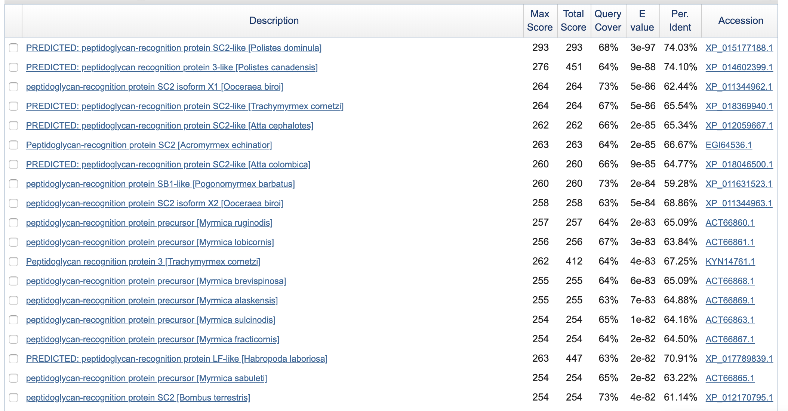
The top hits are not exact matches, but appear to be related to the function from the original A. mellifera gene, as well as other closely related species, suggesting there is homology among these sequences, and potentially similar function in this V. squamosa sequence.

[Q5]
Generate a multiple sequence alignment with your novel protein, your original query protein, and a group of other members of this family from different species. A typical number of proteins to use in a multiple sequence alignment for this assignment purpose is a minimum of 5 and a maximum of 20 - although the exact number is up to you. Include the multiple sequence alignment in your report. Use Courier font with a size appropriate to fit page width.

List of sequences used for multiple alignment using MUSCLE (EBI); the first if the original Apis mellifera reference sequence, the second is the presumed Vespula squamosa sequence, and the other 9 are sequences from other Hymenoptera.

>NP_001157188.1 peptidoglycan-recognition protein S2 precursor [Apis mellifera]
MTKLIAVLFLLVNCQILFCSVHETPVRPRIISRSEWGARKPTTTIRALAQNPPPFVIIHHSATDSCITQA
ICNARVRSFQNYHIDEKGWGDIGYQFLVGEDGNIYEGRGWDKHGAHSISYNSKSIGICIIGNFVGHTPNA
AAIEATKNLISYGVAIGKIQSNYTLLGHRQTTRTSCPGDSLYELIKTWPHWSSI
>GW790304.1_3 QP_B1_I03_041 Caste=Queen, Stage=Pupa Vespula squamosa cDNA, mRNA sequence
RMVRATFLLVATCIAICRAAEVADSAATFETPNIVSRQQWGAKPPKSPTPNLKMNPPPYV
VIHHSDSVGCTTQAICQARVRSFQNDHMNSRKWNDIGYNFLVGEDGNVYEGRGWGKHGSH
SVPYNAKSIGICLIGKFNNNVPNSASIRATQNLIAYGVANNKIKSDYKLLGHRQTTKTDC
PGNSLYNLIKTWPHWTDTP*EI*SLCD*INLPSITSYCFGLDDHWKLTIIGSITFVDFSL
INDGYLQIRFSCEHFYLMFRKGRX
>XP_011344962.1 peptidoglycan-recognition protein SC2 isoform X1 [Ooceraea biroi]
MYIARRTTVLIFAAVYVTLVAQEAAARPNTGGQIIPNIISRAQWGAKSPKSPLSNLAKKPAPYVIIHHST
DTGCETQALCQAKVRGFQNYHMNSKGWTDIGYNFLVGEDGNVYEGRGWGKKGSHSKPFNGKSIGICIIGD
YSNRTPKPAAVQAVSKLIAYGVSNDEIKSDYILLGHRQTGQTTCPGNSLYGMIKSWPHWQSSA
>XP_011631523.1 peptidoglycan-recognition protein SB1-like [Pogonomyrmex barbatus]
MYITKRTTLIFATVYVTLIVQETVATSPNIISRSEWGARAPKSRAPNLKLKPAPYVLIHHSTGSGCETQA
LCQLKVRQFQNEHMNTKGWSDIGYNFLVGEDGNVYEGRGWGKQGAHSIPFNKKSIGICIIGDYRKRTPNA
MAVQAVANLIAQGVQNGEIKSDYKLLGHRQTWPTICPGDSLYTMIKSWPHWSERE
>XP_012170795.1 peptidoglycan-recognition protein SC2 [Bombus terrestris]
MTKLIAVILLLASCQVLFCAVHKTPVRPSIISRSEWGANAPKSTLRNLAEEPAPFVIIHHSASDSCTTRA
ICQARVRSFQNHHMNQKGWNDIGYNFLVGEDGNIYEGRGWGKHGAHSTPYNSKSIGICMIGNFVGHNPSA
AAIKAVKDLIEYGVTLGKIQENYTLLGHRQTTSTSCPGDSLYQLIQTWPHWSSI
>XP_011143830.1 peptidoglycan-recognition protein SC2 isoform X1 [Harpegnathos saltator]
MFVATSTSAVFIAAAYLTLLIPETAATAPTIISRAQWGARAPKHQAANLARKPAPYVVLHHSTGNGCVTQ
AICQLKVREFQNYHMNSKKWSDVGYNFIVGEDGNIYEGRGWGKQGAHSKPFNNKSIGICIIGDYTNRTPN
SAAVQAVDSLIAYGVSSGEIKNDYKLLGHRQTWQTNCPGNSLYTMMQSWPHWAAAA
>XP_014205259.1 peptidoglycan-recognition protein SC2-like [Copidosoma floridanum]
MGKRVLLFVLMLMVKQGEFWSTKTFENPKFTIITRSEWGAQPPKGNVGSLKTLPATYVVIHHAASLSCTN
RAICQARIRTIQNFHMKTEKLQDIGFNFLVGEDGNVYEGRGWEKAGAHAENFNDKSIGICVIGNFDKTSP
SHATLAAIKNLISHGVSQGKLNSQYILIGHRQAETLSCPGHYLYQLIQTWSHWRKISQNAA
>XP_017886197.1 peptidoglycan-recognition protein SB1-like [Ceratina calcarata]
MPVFKLVVAFNYLLLIVPTYSLNTVEIVPNIISRQNWHARQPVERELLEVTPTPYVVIHHGGEPKYCYDE
KTCSAIVRQYQNFHIDDRHWFDIGYSFVIGEDGNVYEGRGWDYVGAHAPGYNTQSIGICIIGDFSNFVPN
EKALKTLNDLIKYGVKLRKIRGDYHILGHRQARSTLCPGTAFYKYVQTLPRWTNHPIPNYSNGTTTTLAL
>XP_028138990.1 peptidoglycan-recognition protein 2-like [Diabrotica virgifera virgifera]
MIYSRYLWIVCVVLSLFYQTNCECPKIYTRNEWSARKALSTRPLREDPPPYVVVHHSATRSCFSVEDCSK
LVKSIQDYHIDHNGWDDIGYNFLIGGDGTIYEGRGYGLHGAHSIPYNARSLGVCLLGSFKDTNPPNVQLK
ALEDFLSCAAADHKIIADYHLIGHRQADKTECPGDRVHAVIEKWPHFEANPQDASPKKL
>NP_001037560.1 peptidoglycan recognition protein S2 precursor [Bombyx mori]
MLVAPSLLLLVFLVSFGTLNAASECGEIPITEWSGTESRRKQPLKSPIDLVVIQHTVSNDCFTDEECLLS
VNSLRQHHMRLAGFKDLGYSFVAGGNGKIYEGAGWNHIGAHTLHYNNISIGIGFIGDFREKLPTQQALQA
VQDFLACGVENNLLTEDYHVVGHQQLINTLSPGAVLQSEIESWPHWLDNARKVLG
>ALN97023.1 peptidoglycan recognition protein S2 [Microplitis mediator]
MFYVIEVILLNALFAFAAGQSTVNIISRQEWGARLPKEPPINLTINPPAFIVIHHSGRGAGCTTQALCQA
KVRSFQDFHMDFREWDDIGYNYLIGEDGNVYEGRGWGIKGAHFPAYNARSLGLCFIGNFDKKIPAPAAIK
TAKNFLDYAVTLGKLQSNYTLIGHRQGRSTTCPGDKLFELIQSWPKWKNVTTD

I ran the MUSCLE with default parameters to produce the following ClustalW output:
CLUSTAL multiple sequence alignment by MUSCLE (3.8)

NP_001037560.1 MLVAPSLLLLVFLVSFGTLNAASEC-----------GEIPITEWSGTESRRKQP--LKSP
XP_028138990.1 ---MIYSRYLWIVCVVLSLFYQTNCEC--------PKIYTRNEWSARKALSTRP-LREDP
XP_017886197.1 ----MPVFKLVVAFNYLLLIVPTYSLNT-V--EIVPNIISRQNWHARQPVEREL-LEVTP
XP_014205259.1 MGKRVLLFVLMLMVKQGEFWSTKTFENP------KFTIITRSEWGAQPPKGNVGSLKTLP
ALN97023.1 --MFYVIEVILLNALFAFAAGQSTV-----------NIISRQEWGARLPKEPPINLTINP
XP_011143830.1 MFVATSTSAVFIAAAYLTLLIPETAATA-------PTIISRAQWGARAPKHQAANLARKP
XP_011344962.1 MYIARRTTVLIFAAVYVTLVAQEAAARPNTGGQIIPNIISRAQWGAKSPKSPLSNLAKKP
XP_011631523.1 MYITKRTT-LIFATVYVTLIVQETVATS-------PNIISRSEWGARAPKSRAPNLKLKP
GW790304.1_3 --RMVRATFLLVATCIAICRAAEVADSAAT--FETPNIVSRQQWGAKPPKSPTPNLKMNP
NP_001157188.1 MTKLIAVLFLLVNCQILFCSVHETPVR--------PRIISRSEWGARKPTTTIRALAQNP
XP_012170795.1 MTKLIAVILLLASCQVLFCAVHKTPVR--------PSIISRSEWGANAPKSTLRNLAEEP
: . :* . . *

NP_001037560.1 IDLVVIQHTV-SNDCFTDEECLLSVNSLRQHHMRLAGFKDLGYSFVAGGNGKIYEGAGWN
XP_028138990.1 PPYVVVHHSA-TRSCFSVEDCSKLVKSIQDYHIDHNGWDDIGYNFLIGGDGTIYEGRGYG
XP_017886197.1 TPYVVIHHGGEPKYCYDEKTCSAIVRQYQNFHIDDRHWFDIGYSFVIGEDGNVYEGRGWD
XP_014205259.1 ATYVVIHHAA-SLSCTNRAICQARIRTIQNFHMKTEKLQDIGFNFLVGEDGNVYEGRGWE
ALN97023.1 PAFIVIHHSGRGAGCTTQALCQAKVRSFQDFHMDFREWDDIGYNYLIGEDGNVYEGRGWG
XP_011143830.1 APYVVLHHST-GNGCVTQAICQLKVREFQNYHMNSKKWSDVGYNFIVGEDGNIYEGRGWG
XP_011344962.1 APYVIIHHST-DTGCETQALCQAKVRGFQNYHMNSKGWTDIGYNFLVGEDGNVYEGRGWG
XP_011631523.1 APYVLIHHST-GSGCETQALCQLKVRQFQNEHMNTKGWSDIGYNFLVGEDGNVYEGRGWG
GW790304.1_3 PPYVVIHHSD-SVGCTTQAICQARVRSFQNDHMNSRKWNDIGYNFLVGEDGNVYEGRGWG
NP_001157188.1 PPFVIIHHSA-TDSCITQAICNARVRSFQNYHIDEKGWGDIGYQFLVGEDGNIYEGRGWD
XP_012170795.1 APFVIIHHSA-SDSCTTRAICQARVRSFQNHHMNQKGWNDIGYNFLVGEDGNIYEGRGWG
::::* * * :. .: *: *:*:.:: * :*.:*** *:

NP_001037560.1 HIGAHTLHYNNISIGIGFIGDFREKLPTQQALQAVQDFLACGVENNLLTEDYHVVGHQQL
XP_028138990.1 LHGAHSIPYNARSLGVCLLGSFKDTNPPNVQLKALEDFLSCAAADHKIIADYHLIGHRQA
XP_017886197.1 YVGAHAPGYNTQSIGICIIGDFSNFVPNEKALKTLNDLIKYGVKLRKIRGDYHILGHRQA
XP_014205259.1 KAGAHAENFNDKSIGICVIGNFDKTSPSHATLAAIKNLISHGVSQGKLNSQYILIGHRQA
ALN97023.1 IKGAHFPAYNARSLGLCFIGNFDKKIPAPAAIKTAKNFLDYAVTLGKLQSNYTLIGHRQG
XP_011143830.1 KQGAHSKPFNNKSIGICIIGDYTNRTPNSAAVQAVDSLIAYGVSSGEIKNDYKLLGHRQT
XP_011344962.1 KKGSHSKPFNGKSIGICIIGDYSNRTPKPAAVQAVSKLIAYGVSNDEIKSDYILLGHRQT
XP_011631523.1 KQGAHSIPFNKKSIGICIIGDYRKRTPNAMAVQAVANLIAQGVQNGEIKSDYKLLGHRQT
GW790304.1_3 KHGSHSVPYNAKSIGICLIGKFNNNVPNSASIRATQNLIAYGVANNKIKSDYKLLGHRQT
NP_001157188.1 KHGAHSISYNSKSIGICIIGNFVGHTPNAAAIEATKNLISYGVAIGKIQSNYTLLGHRQT
XP_012170795.1 KHGAHSTPYNSKSIGICMIGNFVGHNPSAAAIKAVKDLIEYGVTLGKIQENYTLLGHRQT
*:* :* *:*: .:*.: * : : .:: .. : :* ::**.*

NP_001037560.1 INTLSPGAVLQSEIESWPHWLDNARKVLG---------
XP_028138990.1 DKTECPGDRVHAVIEKWPHFEANPQDASPKKL------
XP_017886197.1 RSTLCPGTAFYKYVQTLPRWTNHPIPNYSNGTTTTLAL
XP_014205259.1 ETLSCPGHYLYQLIQTWSHWRKISQNAA----------
ALN97023.1 RSTTCPGDKLFELIQSWPKWKNVTTD------------
XP_011143830.1 WQTNCPGNSLYTMMQSWPHWAAAA--------------
XP_011344962.1 GQTTCPGNSLYGMIKSWPHWQSSA--------------
XP_011631523.1 WPTICPGDSLYTMIKSWPHWSERE--------------
GW790304.1_3 TKTDCPGNSLYNLIKTWPHWTDTP--------------
NP_001157188.1 TRTSCPGDSLYELIKTWPHWSSI---------------
XP_012170795.1 TSTSCPGDSLYQLIQTWPHWSSI---------------
.** . ::. ..:

[Q6]
Create a phylogenetic tree, using either a parsimony or distance-based approach. Bootstrapping and tree rooting are optional. Use “simple phylogeny” online from the EBI or any respected phylogeny program (such as MEGA, PAUP, or Phylip). Paste an image of your Cladogram or tree output in your report.

I ported the output from the previous question to Simple Phylogeny (EBI) and asked it to make me a cladogram using default parameters.

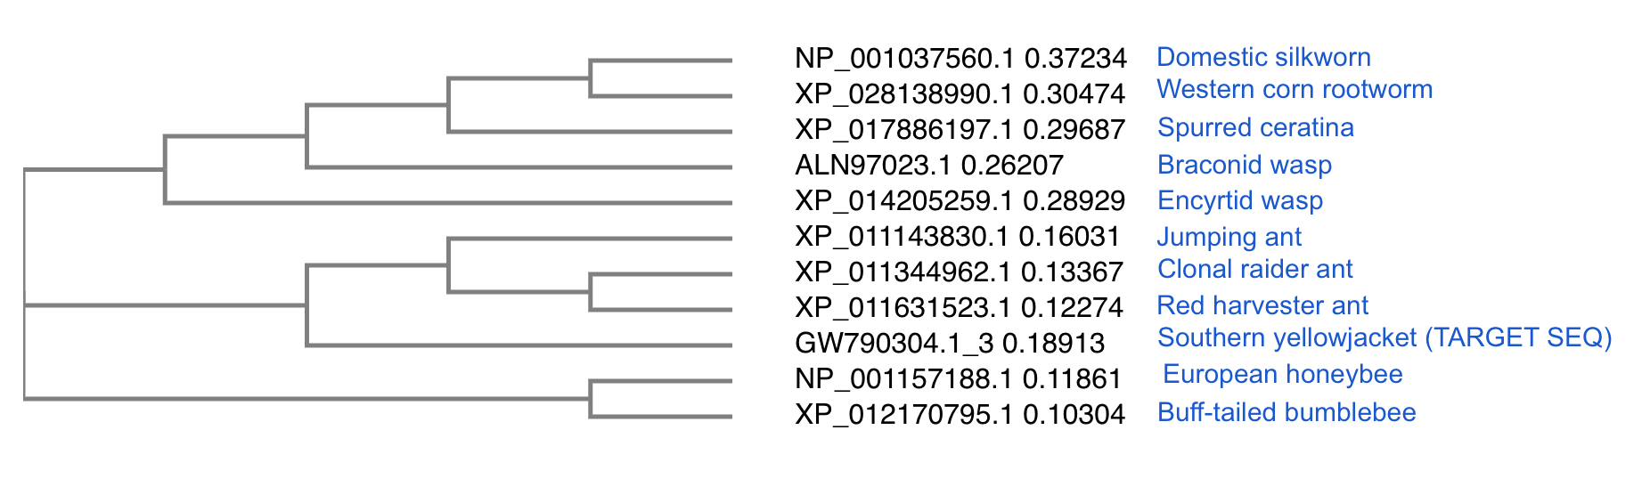
Below is a key describing each branch in order:
>NP_001037560.1 [B. mori] Domestic silkworm (Moth)
>XP_028138990.1 [D. virgifera virgifera] Western corn rootworm (Beetle)
>XP_017886197.1 [C. calcarata] Spurred ceratina (Apid bee)
>ALN97023.1 [M. mediator] NCN (Braconid wasp)
>XP_014205259.1 [C. floridanum] NCN (Encyrtid wasp)
>XP_011143830.1 [H. saltator] Jumping ant (Ant)
>XP_011344962.1 [O. biroi] Clonal raider ant (Ant)
>XP_011631523.1 [P. barbatus] Red harvester ant (Ant)
>GW790304.1_3 [V. squamosa, Target] Southern yellowjacket (Vespid wasp)
>NP_001157188.1 [A. mellifera] European honeybee (Apid bee)
>XP_012170795.1 [B. terrestris] Buff-tailed bumblebee (Apid bee)

As an interesting note, we see that the largely solitary hymenoptera (the Ceratina and parasitic wasps) cluster with the outgroup moth and beetle, whereas the highly social lineages (the ants, bumblebees, yellowjackets and honey bees) cluster together. It's not particularly relevant for this project, but it's cool to know that this supports the current hypothesis that social living deeply affects immune response in Hymenoptera, notably a reduction in function of individual immunes genes in favor of social behaviors that support group immunity.

[Q7]
Generate a sequence identity based heatmap of your aligned sequences using R.
If necessary convert your sequence alignment to the ubiquitous FASTA format (Seaview can read in clustal format and “Save as” FASTA format for example). Read this FASTA format alignment into R with the help of functions in the Bio3D package. Calculate a sequence identity matrix (again using a function within the Bio3D package). Then generate a heatmap plot and add to your report. Do make sure your labels are visible and not cut at the figure margins.
I regenerated the tree from [Q6] as a Pearson/FASTA file (aln-fasta.txt) in Simple Phylogeny and used the following code to create a heatmap:
pgrp <- read.fasta("aln-fasta.txt") # This file contains aligned sequences
head(pgrp)
alnpgrp <- seqidentity(pgrp)
head(alnpgrp) # Perfect!
rc <- rainbow(nrow(alnpgrp), start = 0, end = 1)
cc <- rainbow(ncol(alnpgrp), start = 0, end = 1)
Rnames <- cbind("B. mori (Moth)", "D. virgifera virgifera (Beetle)", "C. calcarata (semi-social Apid bee)", "M. mediator (Braconid wasp)", "C. floridanum (Encyrtid wasp)", "H. saltator (Ant)", "O. biroi (Ant)", "P. barbatus (Ant)", "V. squamosa (social Vespid wasp)", "A. mellifera (social Apid bee)", "B. terrestris (social Apid bee)")
hm_pgrp <- heatmap(alnpgrp, labRow = Rnames, margins = c(9,9))

[Q8]
Using R/Bio3D (or an online blast server if you prefer), search the main protein structure database for the most similar atomic resolution structures to your aligned sequences.
List the top 3 unique hits (i.e. not hits representing different chains from the same structure) along with their Evalue and sequence identity to your query. Please also add annotation details of these structures. For example include the annotation terms PDB identifier (structureId), Method used to solve the structure (experimentalTechnique), resolution (resolution), and source organism (source).
HINT: You can use a single sequence from your alignment or generate a consensus sequence from your alignment using the Bio3D function consensus(). The Bio3D functions blast.pdb(), plot.blast() and pdb.annotate() are likely to be of most relevance for completing this task. Note that the results of blast.pdb() contain the hits PDB identifier (or pdb.id) as well as Evalue and identity. The results of pdb.annotate() contain the other annotation terms noted above.
Note that if your consensus sequence has lots of gap positions then it will be better to use an original sequence from the alignment for your search of the PDB. In this case you could chose the sequence with the highest identity to all others in your alignment by calculating the row-wise maximum from your sequence identity matrix.
To find the accession with the greatest similarity to all sequences, I ran the following code:

alnpgrp <- seqidentity(pgrp)
maxid <- apply(alnpgrp, 1, sum) # calculates the row sums; the largest ID score should indicate that it's the most similar to the others.
maxid

# We receive this output:
NP_001037560.1 XP_028138990.1 XP_017886197.1 XP_014205259.1
4.273 4.819 5.152 5.285
ALN97023.1 XP_011143830.1 XP_011344962.1
5.493 6.051 6.235
XP_011631523.1 GW790304.1_3 NP_001157188.1 XP_012170795.1
6.343 6.155 6.226 6.366

From this, we see that XP_012170795.1, the sequence associated with B. terrestris, the buff-tailed bumblebee, has the most homology to the rest of the sequences. Let's use that one to search PDB for sequence files.

Here are the top three hits I got from blast.pdb and annotate.pdb():
# Read in the bombus sequence
bterr <- read.fasta("bterrestris.fasta")
# Use bio3d to run a blastp against the PDB
blastbterr <- blast.pdb(bterr, database = "pdb")
# Now let's make a workable object, like a database
bterr_db <- cbind(blastbterr$hit.tbl$subjectids,
blastbterr$hit.tbl$identity,
blastbterr$hit.tbl$mismatches,
blastbterr$hit.tbl$gapopens,
blastbterr$hit.tbl$evalue
)
colnames(bterr_db) <- cbind("subjectids",
"identity",
"mismatches",
"gapopens",
"evalue"
)
bterr_db <- as.data.frame(bterr_db)
head(bterr_db)

#Here is the output from this code:
> subjectids identity mismatches gapopens evalue pdb.d
1 4Z8I_A 51.553 76 1 4.57e-58 4Z8I_A
2 4ZXM_A 51.553 76 1 6.17e-58 4ZXM_A
3 2F2L_X 46.012 87 1 4.31e-51 2F2L_X

# Now we will ask for the PDB annotations,
# including the stucture IDs and experimental validation info
bterrann <- pdb.annotate(blastbterr$hit.tbl$subjectids)
bterrann$subjectids <- paste(bterr_db$subjectids)

# Let's squish everything together in a big data frame
whole_bterr <- merge.data.frame(bterrann, bterr_db)
# Quick fix to ensure R properly reads the e-value exponential notation.
whole_bterr$evalue <- as.numeric(as.character(whole_bterr$evalue))

abbrev <- as.data.frame(cbind(whole_bterr$subjectids,
whole_bterr$experimentalTechnique,
whole_bterr$resolution,
whole_bterr$source,
whole_bterr$evalue))
colnames(abbrev) <- c("subjectids",
"experimentalTechnique",
"resolution",
"source",
"evalue")
abbrev$evalue <- as.numeric(as.character(abbrev$evalue))
sabbrev <- abbrev[order(abbrev$evalue),]
head(sabbrev)

# This is a roundabout way to do things, but here is the abbreviated ouput
> subjectids experimentalTechnique resolution source evalue
24 4Z8I_A X-RAY DIFFRACTION 2.7 Branchiostoma belcheri 4.57e-58
25 4ZXM_A X-RAY DIFFRACTION 2.8 Branchiostoma belcheri 6.17e-58
14 2F2L_X X-RAY DIFFRACTION 2.1 Drosophila melanogaster 4.31e-51

[Q9]
Generate a molecular figure of one of your identified PDB structures using VMD. You can optionally highlight conserved residues that are likely to be functional. Please use a white or transparent background for your figure (i.e. not the default black).
Based on sequence similarity. How likely is this structure to be similar to your “novel” protein?

[Q10]
Perform a “Target” search of ChEMBEL ( https://www.ebi.ac.uk/chembl/ ) with your novel sequence. Are there any Target Associated Assays and ligand efficiency data reported that may be useful starting points for exploring potential inhibition of your novel protein?

Scoring Rubric:
[45 total points available]
Q1 (4 points)
Protein name 1
Species 1
Accession number 1
Function known 1
Q2 (6 points)
Blast method 1
Database searched 1
Limits applied 1
Search output list (top hits) 1
Alignment of choice 1
Evalue and other alignment stats 1
Q3 (3 points)
Protein sequence of choice matches Subject above 1
Name in header 1
Species 1
Q4 (3 point)
Blastp output list with identities & Evalue 1
Top alignment shown with alignment statistics 1
Results indicates a “novel” gene found 1
Q5 (3 points)
MSA labeled with useful names 1
MSA trimmed appropriately (i.e. no gap overhangs) 1
Pasted MSA fits report page width (i.e. font, format) 1
Q6 (1 point)
Figure illustrates sequence clustering pattern 1
Q7 (10 points)
Heatmap figure included in report 5
Heatmap is legible (i.e. no labels obscured) 5
Q8 (10 points)
PDB identifiers from multiple species reported 5
Annotation of PDB source, resolution and technique 4
Annotation of Evalue and Sequence Identity 1
Q9 (4 points)
Structure figure provided 2
Uses white background for molecular figure 1
Figure of high resolution (i.e. not just snapshot) 1
Q10 (1 point)
Evidence of ChEMBEL searches 1

